**Grosvenor School of Art, London, 1925-1940**

The Grosvenor School of Art – also known as the Grosvenor School of Modern Art - was founded by Scottish artist and printmaker Iain McNab in 1925. In 1940 it merged with the more traditional Heatherley’s Art School, which is still operating in London. The Grosvenor was famous across Britain and the British Empire in the interwar period for promoting modernist art and design. Its contribution to introducing and acclimatising continental modernism to an extended anglophile audience was substantial. Pupils came from Canada, Australia and New Zealand as well as other countries and through them the experience of modernism was communicated back to their homelands. George Bell’s teaching at his modern art school in central Melbourne, Australia was substantially informed by his studies at the Grosvenor School, as was Dorrit Black who taught contemporary art in Sydney and Adelaide. These teachers established clusters of modernist acolytes, extending the Grosvenor School influence even further. Across the empire the Grosvenor School made modernism acceptable and praiseworthy, representing the authority of what Australian artist Arthur Streeton called “the Centre of Empire” combined with the social and glamorous cachet that London symbolised for the social elites in the colonies. News about the school found its way to the social, art and literary pages of newspapers across the Empire, particularly noting the activities of children from prominent families at the school.

The Grosvenor School’s accessible and lively vision of contemporary art and design also reinforced its influence. Students did not have to present with formal prerequisites or qualifications to enrol and could join at any time within a semester, meaning that overseas students did not have to wait until a new term started. They could also pick and choose whatever subjects appealed to them. Expatriates already established in London, such as the New Zealand born art dealer Rex Nan Kivell (1898-1977), recommended the school to newer arrivals and co-nationals. For some students, the fact that the school remained within the Anglosphere and did not demand adjustment to foreign languages and cultures may have been a point in its favour. Although some artists combined studies at the Grosvenor with studies in Europe: Russell Drysdale (1912-1981) studied at La Grande Chaumiere and Helen Stewart (1900-1983) with Andre Lhote. Remarkably the school was not a finishing school for dilettantes, it was well furnished with everything from printmaking equipment to a commercial kitchen to serve meals onsite. The staff were outstanding personalities of their era, including Sybil Andrews, hailed as a major figure of both British and later Canadian modernism, who lived long enough to witness her modernist work return to favour. Equally the tuition was effective, promoting in its attendees a rigorous sense of linear clarity and awareness of pattern and design. A reviewer in the *Sydney Morning Herald* attributed a new sense of strength in draughtsmanship and composition in the work of an artist who had returned from their studies at the Grosvenor School.

In public and curatorial memory the Grosvenor School is associated most frequently with the now highly sought after oeuvre of coloured lino cuts that were produced by Claude Flight (1881-1955) and his students. These prints were greatly celebrated at the time of their making as a genuine innovation in art, democratic and modern and although they were priced far above a working class income, they were a conscious attempt to make avant-garde art truly reflect ordinary proletarian life, as with post revolution Russian experiments with popular art forms. They also embraced stylistic and technical innovation, doing away with the monochrome key block, making the areas of different colours carry and form the composition itself rather than just filling in established contours. The prints generally expressed a futurist dynamic, seeking to render speed and energy visible with compositional lines, visual distortions and optical illusions. They celebrated aspects of modern life including streetscapes, public transport, organised sport and funfairs/amusement parks.

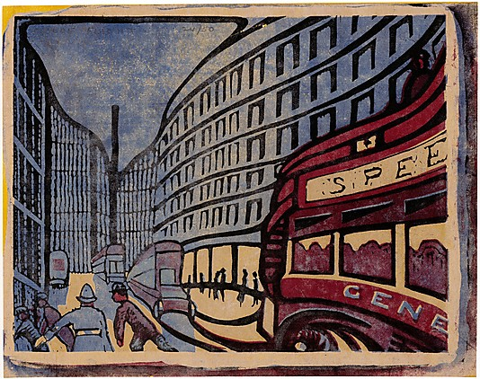

Claude Flight, *Speed*, 1923, linoleum cut, 24.6 x 31.1 cm, Metropolitan Museum of Art.

Whilst Flight was hailed as England’s true Futurist, his genial vision did not extend to the militaristic and politicised vision of Italian Futurism. It is generally believed that Flight met Marinetti in 1912 when the latter visited London. For a brief period, less than a decade, the linocuts were wildly popular, finding buyers in commercial galleries. They were also exhibited in many public galleries, 12,000 people viewing one touring exhibition in Britain alone, and acquired as examples of contemporary art by major institutions. By the advent of the Second World War the moment of collective and radical utopianism in the production and dissemination of art, that the prints were intended to have signified, was over. Only in the 1970s did the prints begin to recapture curatorial favour and significant survey exhibitions were organised by public galleries as early as the 1980s in Britain, Australia and the United States.

Beyond printmaking, the Grosvenor school supported modernist endeavours in a wide range of disciplines, hosting exhibitions of handmade book production, printing and bookbinding, modernist textiles for the home and modernist accessories for dining and cooking, to name a random selection. Art theoretical subjects were also taught, with Frank Rutter lecturing on recent art history including Picasso. As with a Parisian academy, the life class was a central focus of school life and routine. The school’s creative ethos was cosmopolitan, drawing upon the expected School of Paris influences but also Italian Futurism and, in the case of Claude Flight, the theories of the Viennese Franz Czizek (1865-1946). Pupils came from beyond the British Empire, with the Swiss artist Lilli Tschudi (1911-2004) being the most high profiled. Exhibitions of student work were seen in places as scattered as New York, Shanghai and Melbourne during the 1920s and 1930s.

**References and Further Reading**

Coppel, S. (1995) *Linocuts of the Machine Age: Claude Flight and the Grosvenor School*, Aldershot, Scholar Press

The most detailed of a series of research publications around the linocuts of the Grosvenor School by one of the key specialists in this field

O'Mahony, M., (2011) “Imaging Sport at the Grosvenor School of Modern Art (1929–37)”, *The International Journal of the History of Sport*, 28, 8-9 online N.P.

Parkin, M., (1987) “Claude Flight and the Linocut”, *The Journal of Decorative and Propaganda Arts,* 6: 26-33.

Samuel, G. with Penny, N., (2002) *The Cutting Edge of Modernity: Linocuts of the Grosvenor School*, Aldershot. Lund Humphires.

A small but richly illustrated anthology of Grosvenor School linocuts